**Introduction**

**Project Setup**  
* We’ll use **create-react-app.**  
* More complex React apps need a more complex build configuration where multiple build steps are executed to give you a pleasant developer experience and still make the code work in older browsers too.  
* And therefore we don’t want to set this up on our own.  
* **This package has TypeScript support built-in already and therefore it’s super simple to use TypeScript in a React aplicaiton these days**.  
**npm install -g create-react-app  
create-react-app . --scripts-version=react-scripts-ts**  
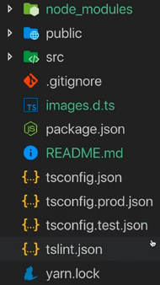  
* **You can always adjust the TypeScript settings in the tsconfig files**.  
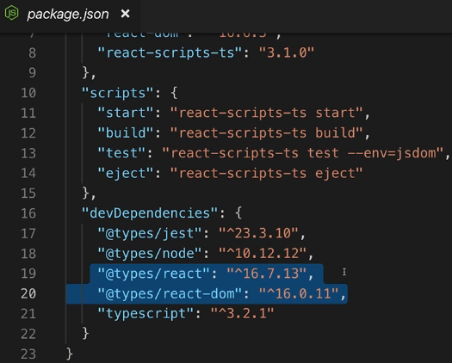  
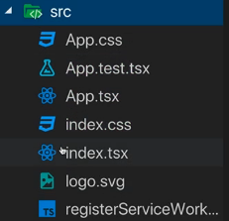  
* **tsx** is a special file ending used in React apps mostly, React uses a feature called JSX which basically allows you to write HTML-ish syntax in your JavaScript files and this is compiled down to normal JavaScript by the build setup.  
**npm start**  
* It will automatically watch for changes.  
**Using PropTypes**  
* Let me now briefly show you some nice things you can do with TypeScript in a React project.  
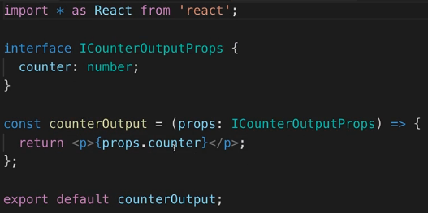  
* **Adding I in front of the interface name is a special syntax this React project wants**.  
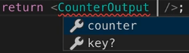  
* **I even get autocompletion thanks to the type setup where we define the CounterOutputProps**.  
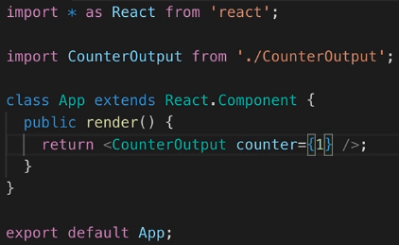

**Types & Class Components**  
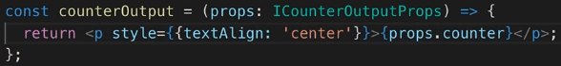  
* **React.Component is a GENERIC class, so we can use this Generic value syntax <Props, State>.**  
* **We can pass an empty object {}.**  
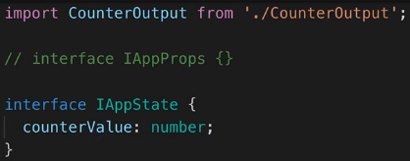  
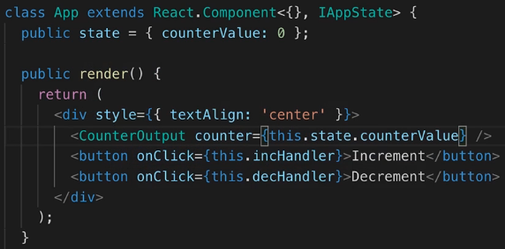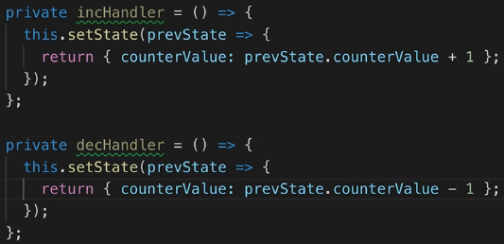  
* **Notice the beautiful autocompletion we get everywhere**.  
* This is a normal React application but it takes advantage of TypeScript for example where we define the type of props and state. And we get a lot of autocompletion everywhere then.

**Wrap Up**  
* **You can play around with the setup and I recommend doing that**.  
* You can also google for React TypeScript and you should find this Github repository on the Microsoft account where you can read way more about setting up this React project using the exact same approach as we did, but then also about the different things you can do there, you can configure there and you can try out there.  
<https://github.com/microsoft/TypeScript-React-Starter>

**Resources**  
TypeScript React  
<https://github.com/microsoft/TypeScript-React-Starter>